Exploring Energy
Science Texts for Close Reading

Solar Energy
Solar energy is a way to harness sunlight for heating or electricity. There are different ways to convert sunlight into usable energy. Concentrated solar power uses mirrors to focus the energy from the sun onto a smaller area. This concentrated thermal energy heats water into steam, which turns a turbine connected to a generator. The generator converts the mechanical energy of the spinning turbine into electrical energy. Concentrated solar power plants need between 500 to over 1,000 acres of land—more than 400 football fields!—to have enough mirrors to generate electricity efficiently. Often they are found in unpopulated desert regions—like the Ivanpah Solar Electric Generating System in the Mojave desert—which means the electricity generated has to be transmitted a long distance to where it will be used. It also means that large regions of desert ecosystems can be impacted.

Radiant energy Thermal energy Mechanical energy Electrical energy
Another technology that can convert the energy of sunlight into electricity is solar photovoltaics (PV). When sunlight strikes a solar photovoltaic cell, it is absorbed by a semiconductor—a material like silicon that can conduct electricity under the right conditions. This excites electrons in the semiconductor, which then flow, generating an electrical current. A bunch of solar photovoltaic cells can be grouped together to create a solar panel. Solar panels can be installed on the roofs of homes and buildings in solar arrays, so they are better options for cities. Solar panels are relatively easy to take care of and aren’t noisy.
Solar photovoltaic technology produces no direct carbon dioxide or other greenhouse gases that can warm the climate. Sunlight is free, abundant, and renewable, since it won’t run out for billions of years. The Earth’s surface continuously receives 10,000 times more energy from the sun than the world currently uses²!
Unfortunately, solar energy isn’t a great option everywhere or all of the time. Regions that don’t get a lot of constant or direct sunlight aren’t ideal places to use solar energy. Solar panels don’t work at night and don’t work as well when it is cloudy. Solar technology is becoming cheaper, but there is a cost to build a large concentrated solar power plant or install solar panels.

Exploring Energy

Weighing the Benefits and Drawbacks of Solar Energy
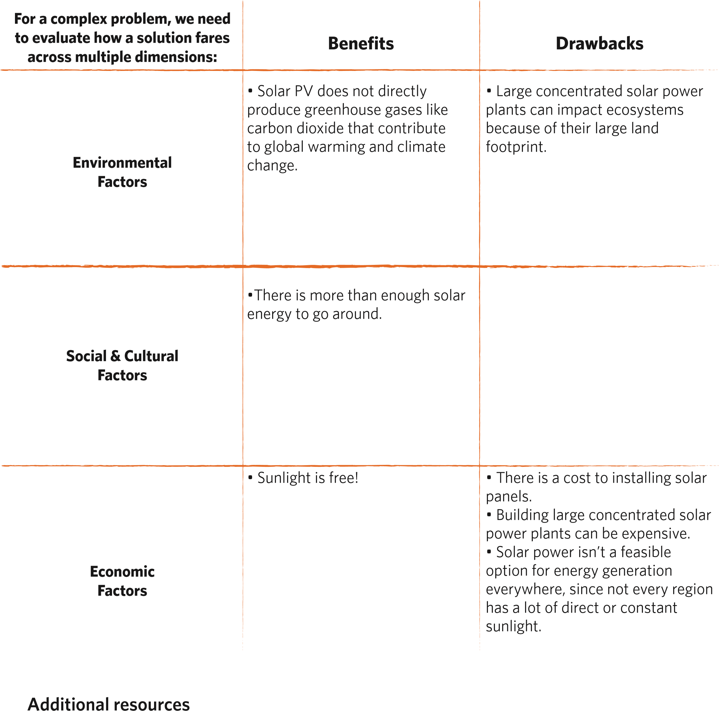
GRID Alternatives: Making solar technology accessible to underserved communities
Solar Energy Basics from the National Renewable Energy Laboratory

Exploring Energy
Science Texts for Close Reading

Geothermal Energy
How is electricity generated at a geothermal power plant? Well, it is often a lot like how electricity is generated at a coal-fired power plant, but with one key difference. In both cases, water is heated into steam, which turns a turbine connected to a generator. The generator converts the mechanical energy of the spinning turbine into electrical energy that can be transmitted to homes and buildings through transmission lines.
In a coal power plant, burning coal supplies the energy to heat the water. This process releases carbon dioxide—a powerful greenhouse gas that contributes to global warming and climate change—and other pollutants that can be harmful to the environment and human health into the atmosphere. But in a geothermal power plant, this energy comes from heat that is already present below the Earth’s surface. Geothermal energy is a good energy option in places where there is hot magma close to the Earth’s surface that naturally heats water in the ground into steam. In such places, geothermal energy is a constant and reliable source of energy.
T h e r m a l e n e r g y Mechanical energy Electrical energy
Compared to coal and other fossil fuels, geothermal energy releases much less carbon dioxide into the atmosphere and produces much less pollution. But geothermal energy isn’t a good option everywhere. The best places for geothermal energy production are where there is a heat source, like magma, close to the Earth’s surface, as well as a constant supply of water in the ground that can be heated into steam. Some water can be pumped back into the ground after it is used, but some of it evaporates into the atmosphere, so over time the water in the ground often needs to be replenished. During a drought, this can be an issue. Also, there is evidence that the pumping of water into and out of the ground associated with geothermal power can generate small earthquakes.
With geothermal energy, there is no fuel cost, since the fuel is naturally-occurring magma. However, upfront costs associated with building a new geothermal power plant and drilling wells to access the steam underground can be high³.

Exploring Energy

Weighing the Benefits and Drawbacks of Geothermal Energy
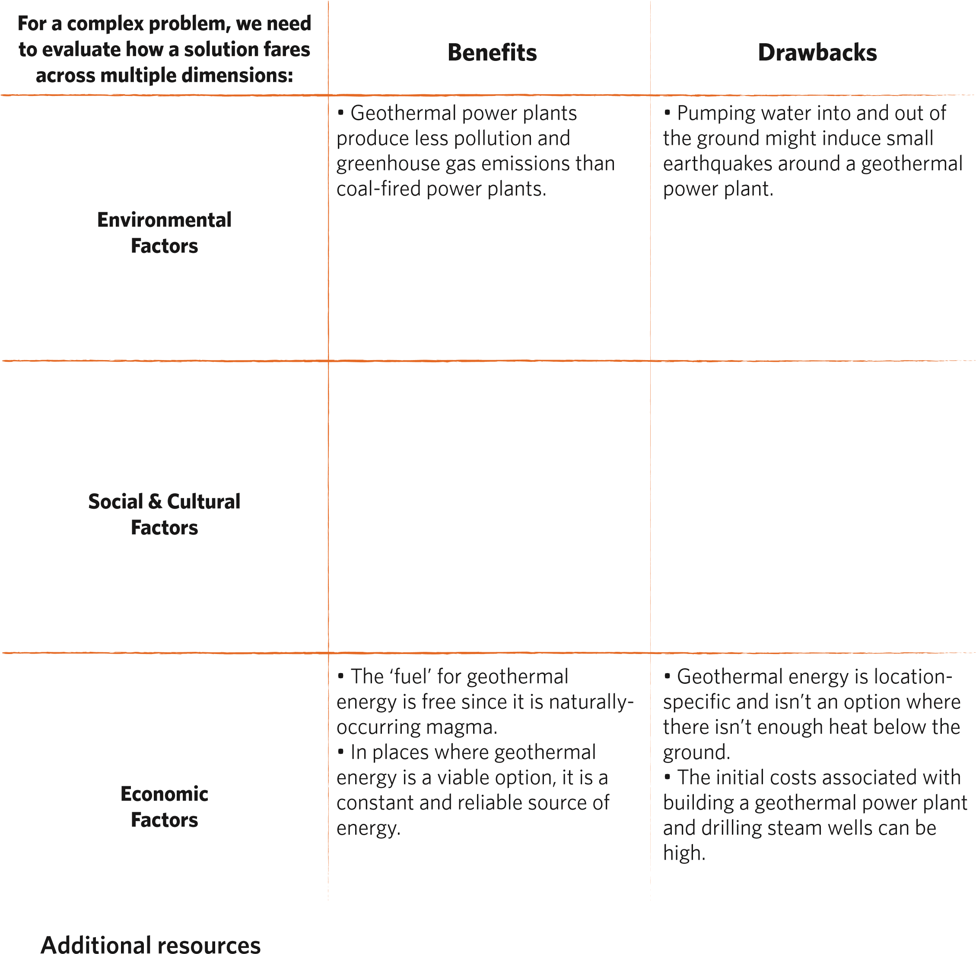
Learn about The Geysers geothermal power plant in California

The New York Times: BrightSource Alters Solar Plant Plan to Address Concerns Over Desert Tortoise (Feb. 2010) 2 U.S. Department of Energy
National Renewable Energy Laboratory: Energy Analysis
University of California, Santa Cruz Newscenter: Geothermal power facility induces earthquakes, study finds 3 Geothermal Energy Association

