Exploring Energy
Science Texts for Close Reading

Hydroelectric Power
Hydroelectric power (or ‘hydropower’) uses the energy of moving water to generate electricity. But how exactly can we capture and transform this energy into usable electricity? One of the main ways to do this is by building a dam on a river. By trapping water behind a dam, we can increase the level of the water behind the dam, building up its potential energy. When special gates in the dam are opened, the water—pulled by gravity—flows down through the dam and through turbines connected to a generator. The potential energy of the water is turned into kinetic energy as it flows, and then mechanical energy that turns the turbines. The generator converts the mechanical energy of the spinning turbines into electrical energy that can be transmitted to homes and buildings through transmission lines.
Potential energy Kinetic energy Mechanical energy Electrical energy
The water reservoirs (lakes and ponds) created behind dams can serve as recreational spaces for people who enjoy fishing, swimming, or boating. The water in these reservoirs can also be used for irrigation in agricultural areas.
Hydropower does not pollute the water nor the air. It also produces no direct carbon dioxide or other greenhouse gases that can cause damage to the climate. However, building a dam on a river can have significant impacts on ecosystems. Some fish species like salmon that migrate seasonally up rivers and streams to spawn are blocked from reaching their spawning destinations by dams. The reservoir created behind a dam often floods land that wasn’t originally underwater. In addition to impacting the plants and animals living on this land, this can displace people too.
Hydropower is reliable as long as there is enough available water. During a drought, this can be a problem. And while flowing water is free, building a dam can be expensive. Dams also don’t just trap water, but anything being moved by the river. Sand and rocks can build up behind a dam over time, not only decreasing the amount of water the dam can store and release, but reducing the amount of sand that is carried into the coastal ocean to supply beaches.

Exploring Energy

Weighing the Benefits and Drawbacks of Hydroelectric Power
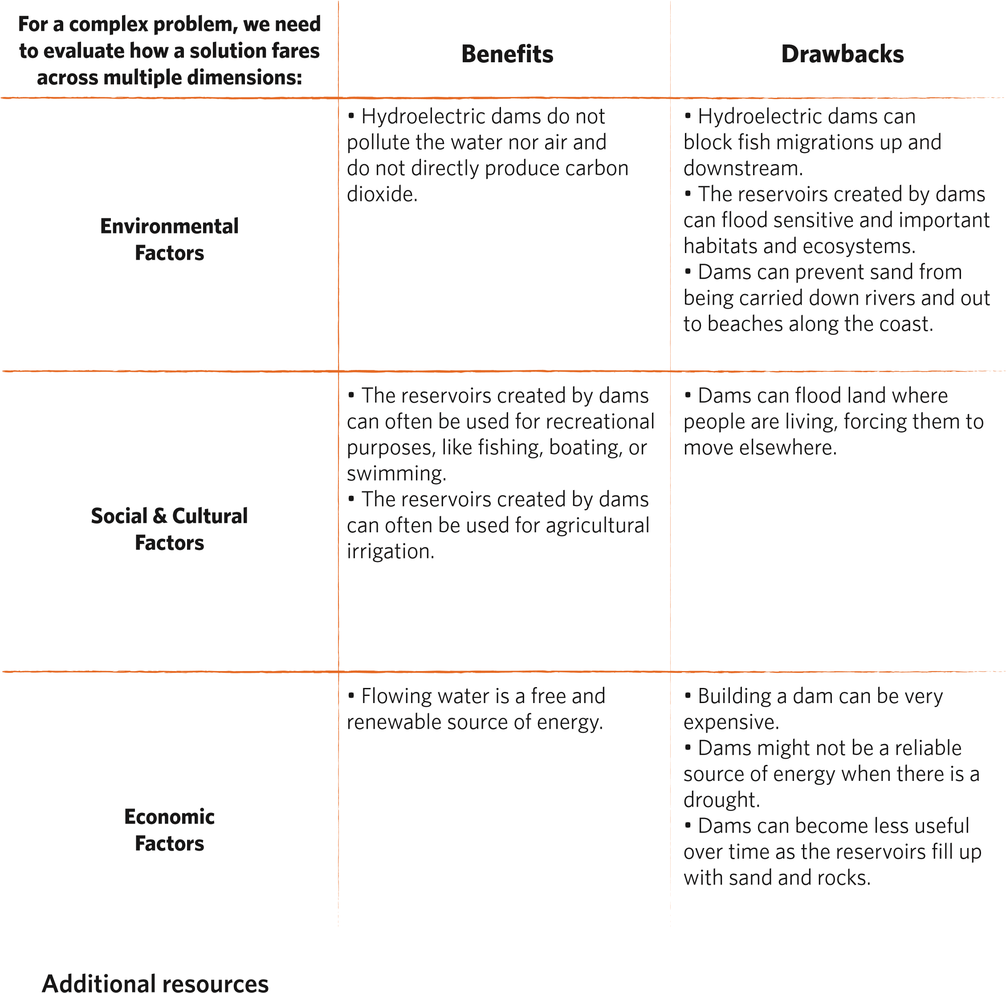
KQED News: California Plumbing: A Mind-Boggling Web

Exploring Energy
Science Texts for Close Reading

Wind Energy
Have you ever tried to make a toy pinwheel spin by blowing on it? We can harness the power of moving air on a much larger scale and use it to produce electricity with wind turbines. When the wind is strong enough (has enough kinetic energy), the blades of a wind turbine turn, which spins a shaft connected to a generator. The generator converts the mechanical energy of the spinning shaft into electrical energy that can be transmitted to homes and buildings through power lines.
Kinetic energy Mechanical energy Electrical energy
There are many different kinds of wind turbines, from small turbines that can be put on the roof of a house to really large turbines that can be built together in wind farms to power entire communities. Wind energy—a renewable resource—can be produced anywhere where there is wind, but the stronger and more consistently the wind blows, the better. Unfortunately, in most places the wind isn’t blowing all of the time, and in places that aren’t very windy, wind turbines probably aren’t a good way to generate reliable electricity.
Wind energy doesn’t directly produce carbon dioxide or other greenhouse gases that can cause damage to the climate. Wind power is also relatively inexpensive. The wind itself is a free resource, and although it costs money to build and operate wind turbines, advancements in technology have significantly reduced these costs over time. Wind energy doesn’t pollute like coal burning, and pollution can cause health problems for people. However, like with any infrastructure, some people express concern about wind turbines being too noisy or ruining the look of a landscape, and therefore don’t necessarily want wind turbines near their homes.
Some kinds of wind turbines, particularly larger ones, can cause harm to birds and bats²; however, people are working on ways to reduce the impact of wind turbines on birds and bats, such as changing the height or location of the turbines.

Exploring Energy

Weighing the Benefits and Drawbacks of Wind Energy
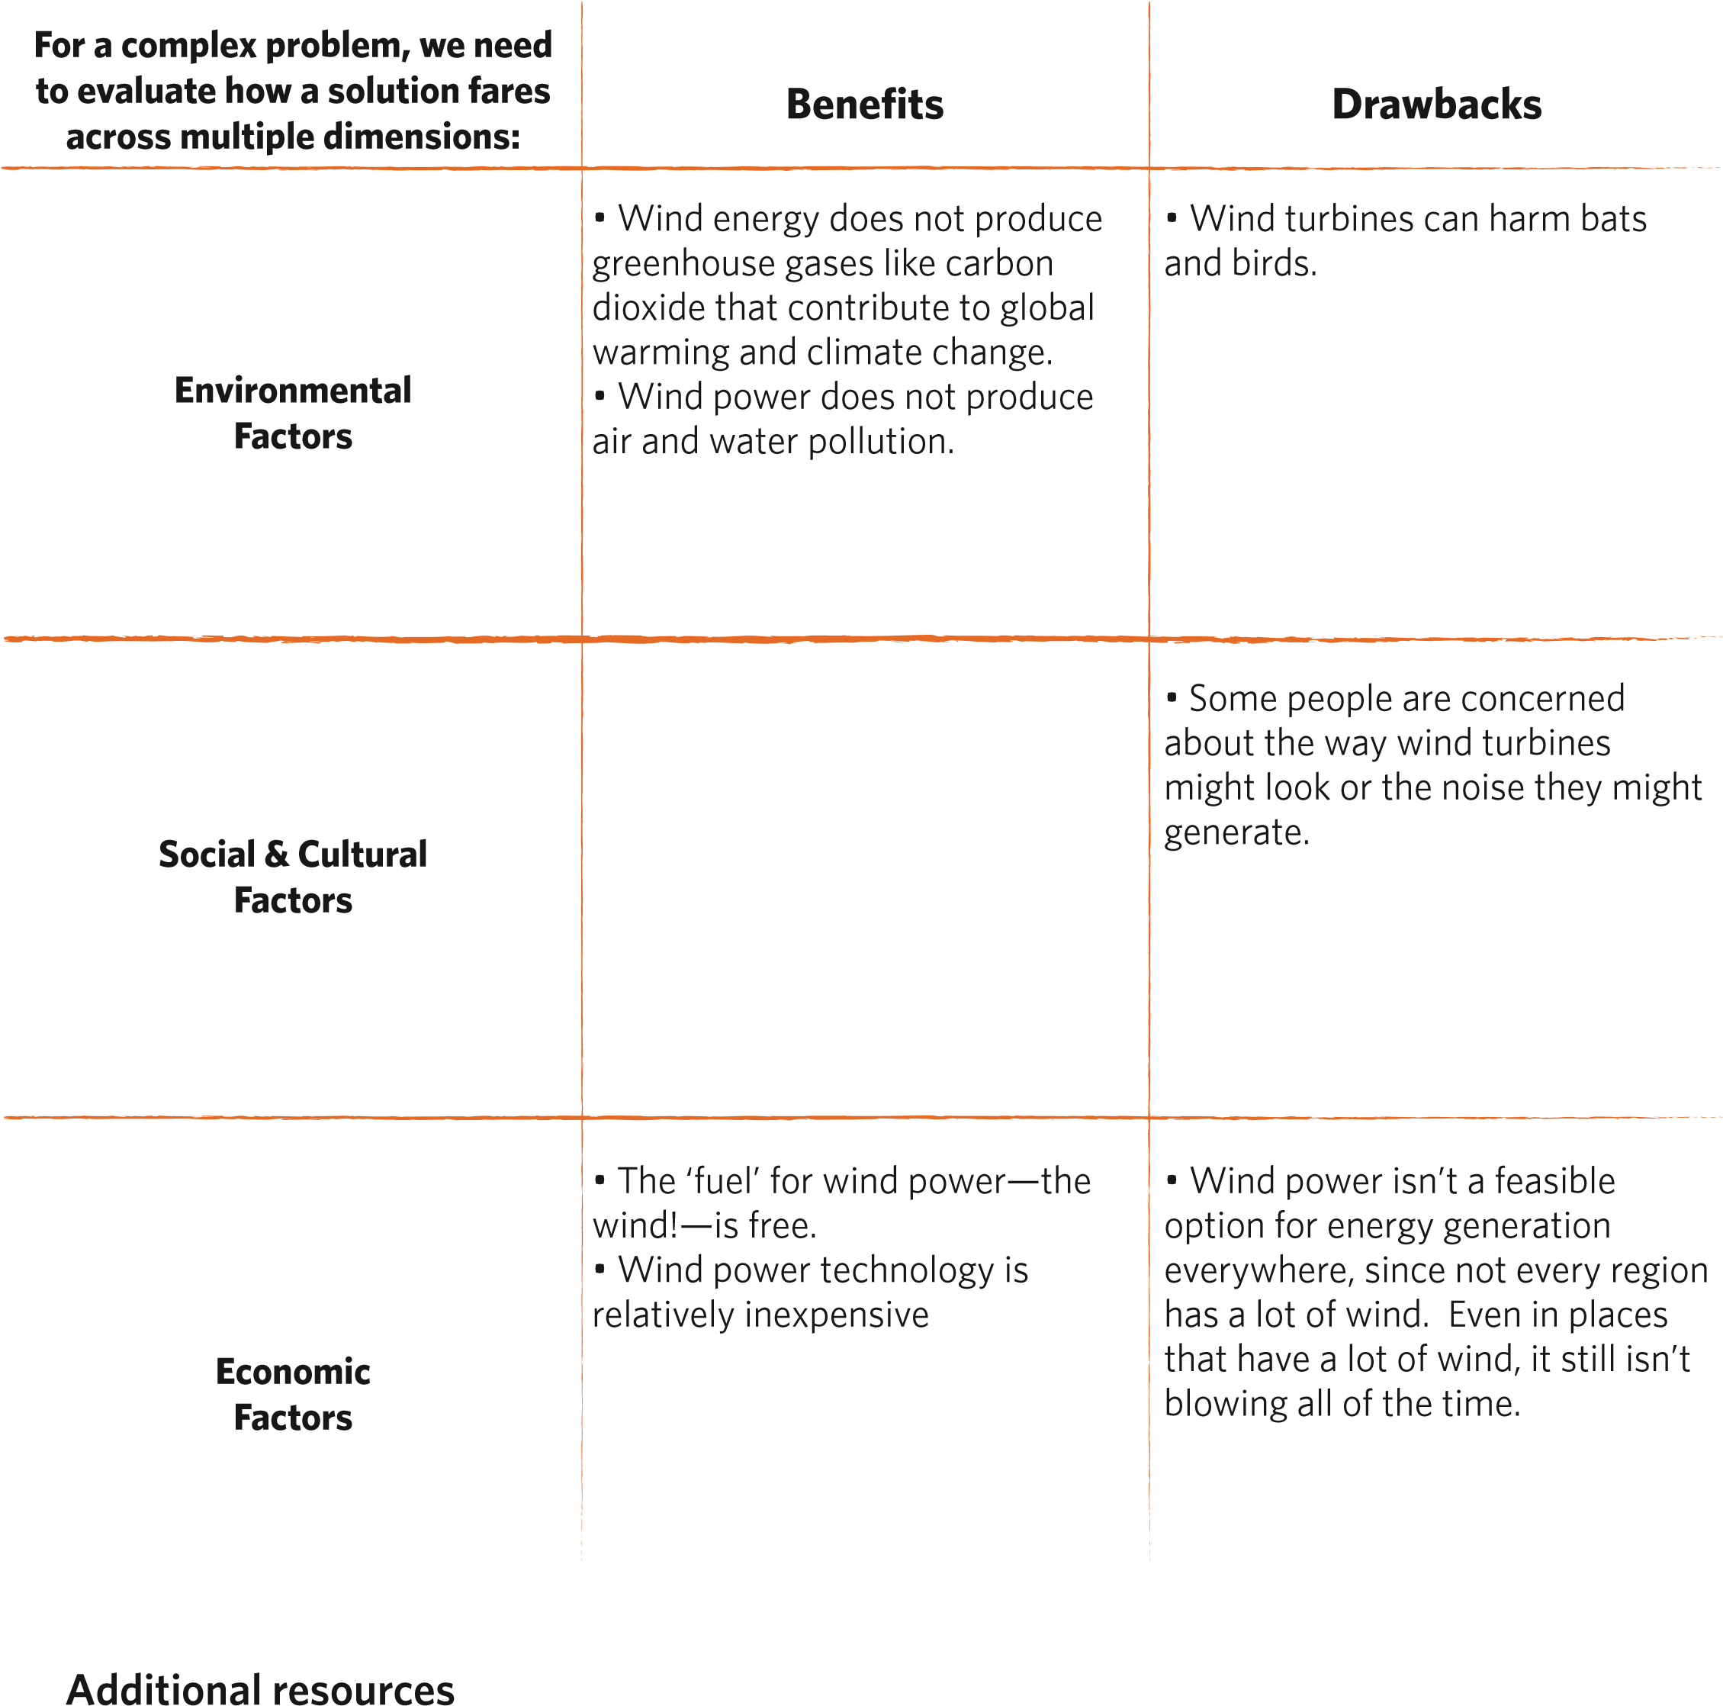
California Academy of Sciences: Our Clean Energy Future
California Academy of Sciences: Birds vs. Energy

NOAA Fisheries: About Dams & Fish
CoastalCare.org: Dams–Cutting Off Our Beach Sand
World Health Organization: What are the effects on health of transport-related air pollution? 2 Smallwood, 2013

