Name: _______________________________________________ Date: _______________ Block: ______
Science Textbook Guide: Erosion by Water (AC)
Directions: Read pages 396-407 from your textbook and complete the following activities.
- Use the word bank below to complete the chart that compares and contrasts erosion and deposition.

- Increases with slower moving water
- Increases with faster moving water
- Occurs more upstream
- Occurs more at the mouth of a river
- Moves sediment from one place to another
- Sets sediment down
- Affects the shape of the river

Erosion | Both | Deposition

- Complete the following chart.

 | Term meaning | How it affects the rate of erosion
Gradient
Load
Discharge

- Describe how the Colorado River created the Grand Canyon. ________________________________________ __________________________________________________________________________________________

- Draw a picture AND describe what occurs to create a floodplain.

- Draw a picture AND describe what occurs to create a marsh.

- Explain how groundwater causes caves to form. ___________________________________________________ __________________________________________________________________________________________
- Make a claim about what happens underground to cause sinkholes to form. State the evidence for your claim and explain your reasoning. ___________________________________________________________________ ______________________________________________________________________________________________________________________________________________________________________________________________________________________________________________________________________________

- Compare and contrast alluvial fans and deltas, including a picture, where they form, and how they form.

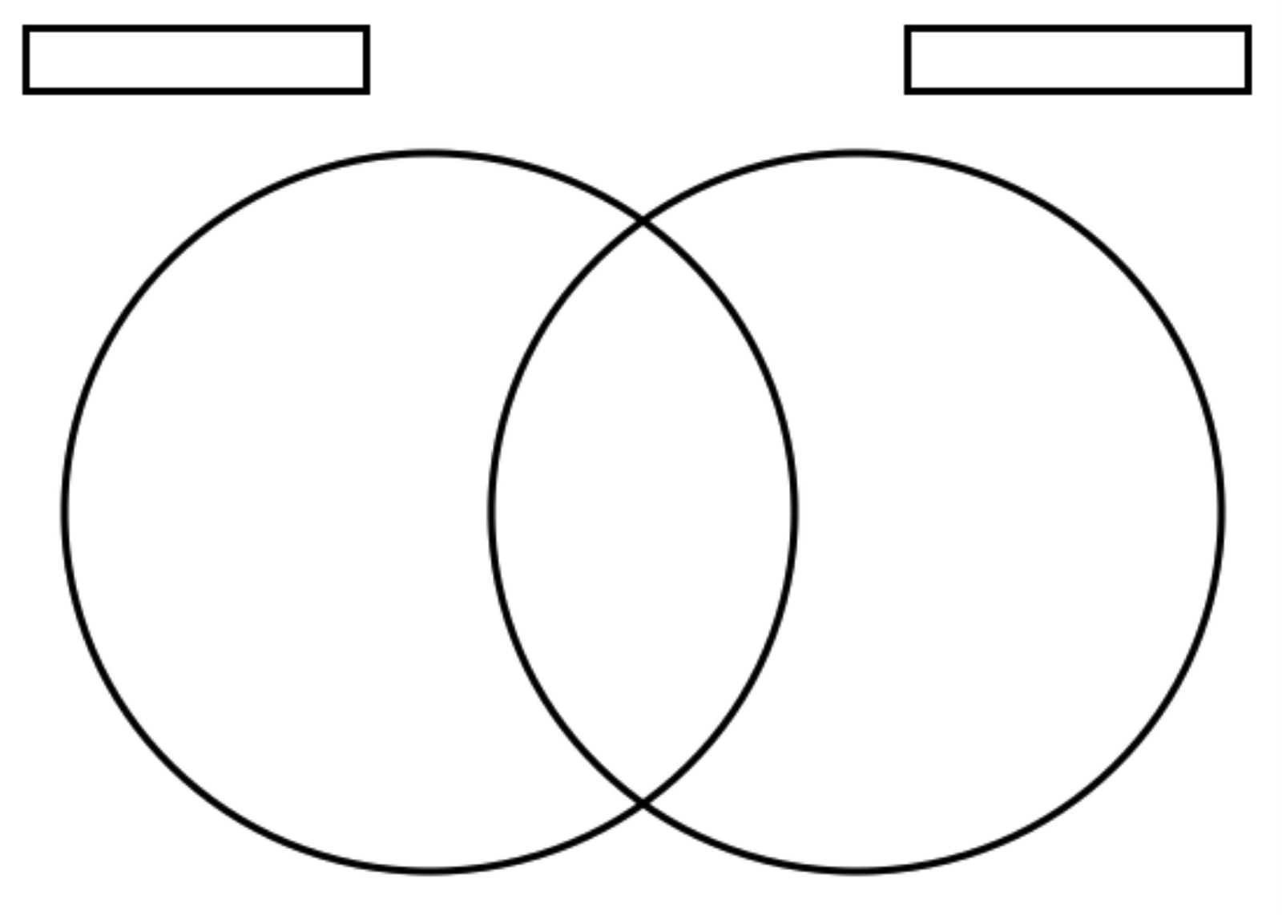

- Complete the following chart.
Coastal landform | How it forms | Appearance description
Headland
Sea cave
Sea arch
Sea stack
Wave-cut platform

- What two types of ocean water movement affect the erosion and deposition of a shoreline? __________________

- Would it take more wave energy to deposit sand or rocks on a beach? Explain. __________________________ ____________________________________________________________________________________________________________________________________________________________________________________

- True or false: Barrier islands can change shape or completely disappear over time. ________________

- Analyze the two diagrams below and explain your prediction of how a sandbar forms; be sure to include the words, erosion, deposition, and energy. __________________________________________________________ ____________________________________________________________________________________________________________________________________________________________________________________

